SWAK Jam Sprite List

Jonah Daggerfell

Pose: Use pose from this sketch, only need to mirror it so it looks from left to right (visual novel sprites for player characters are typically placed on the left).

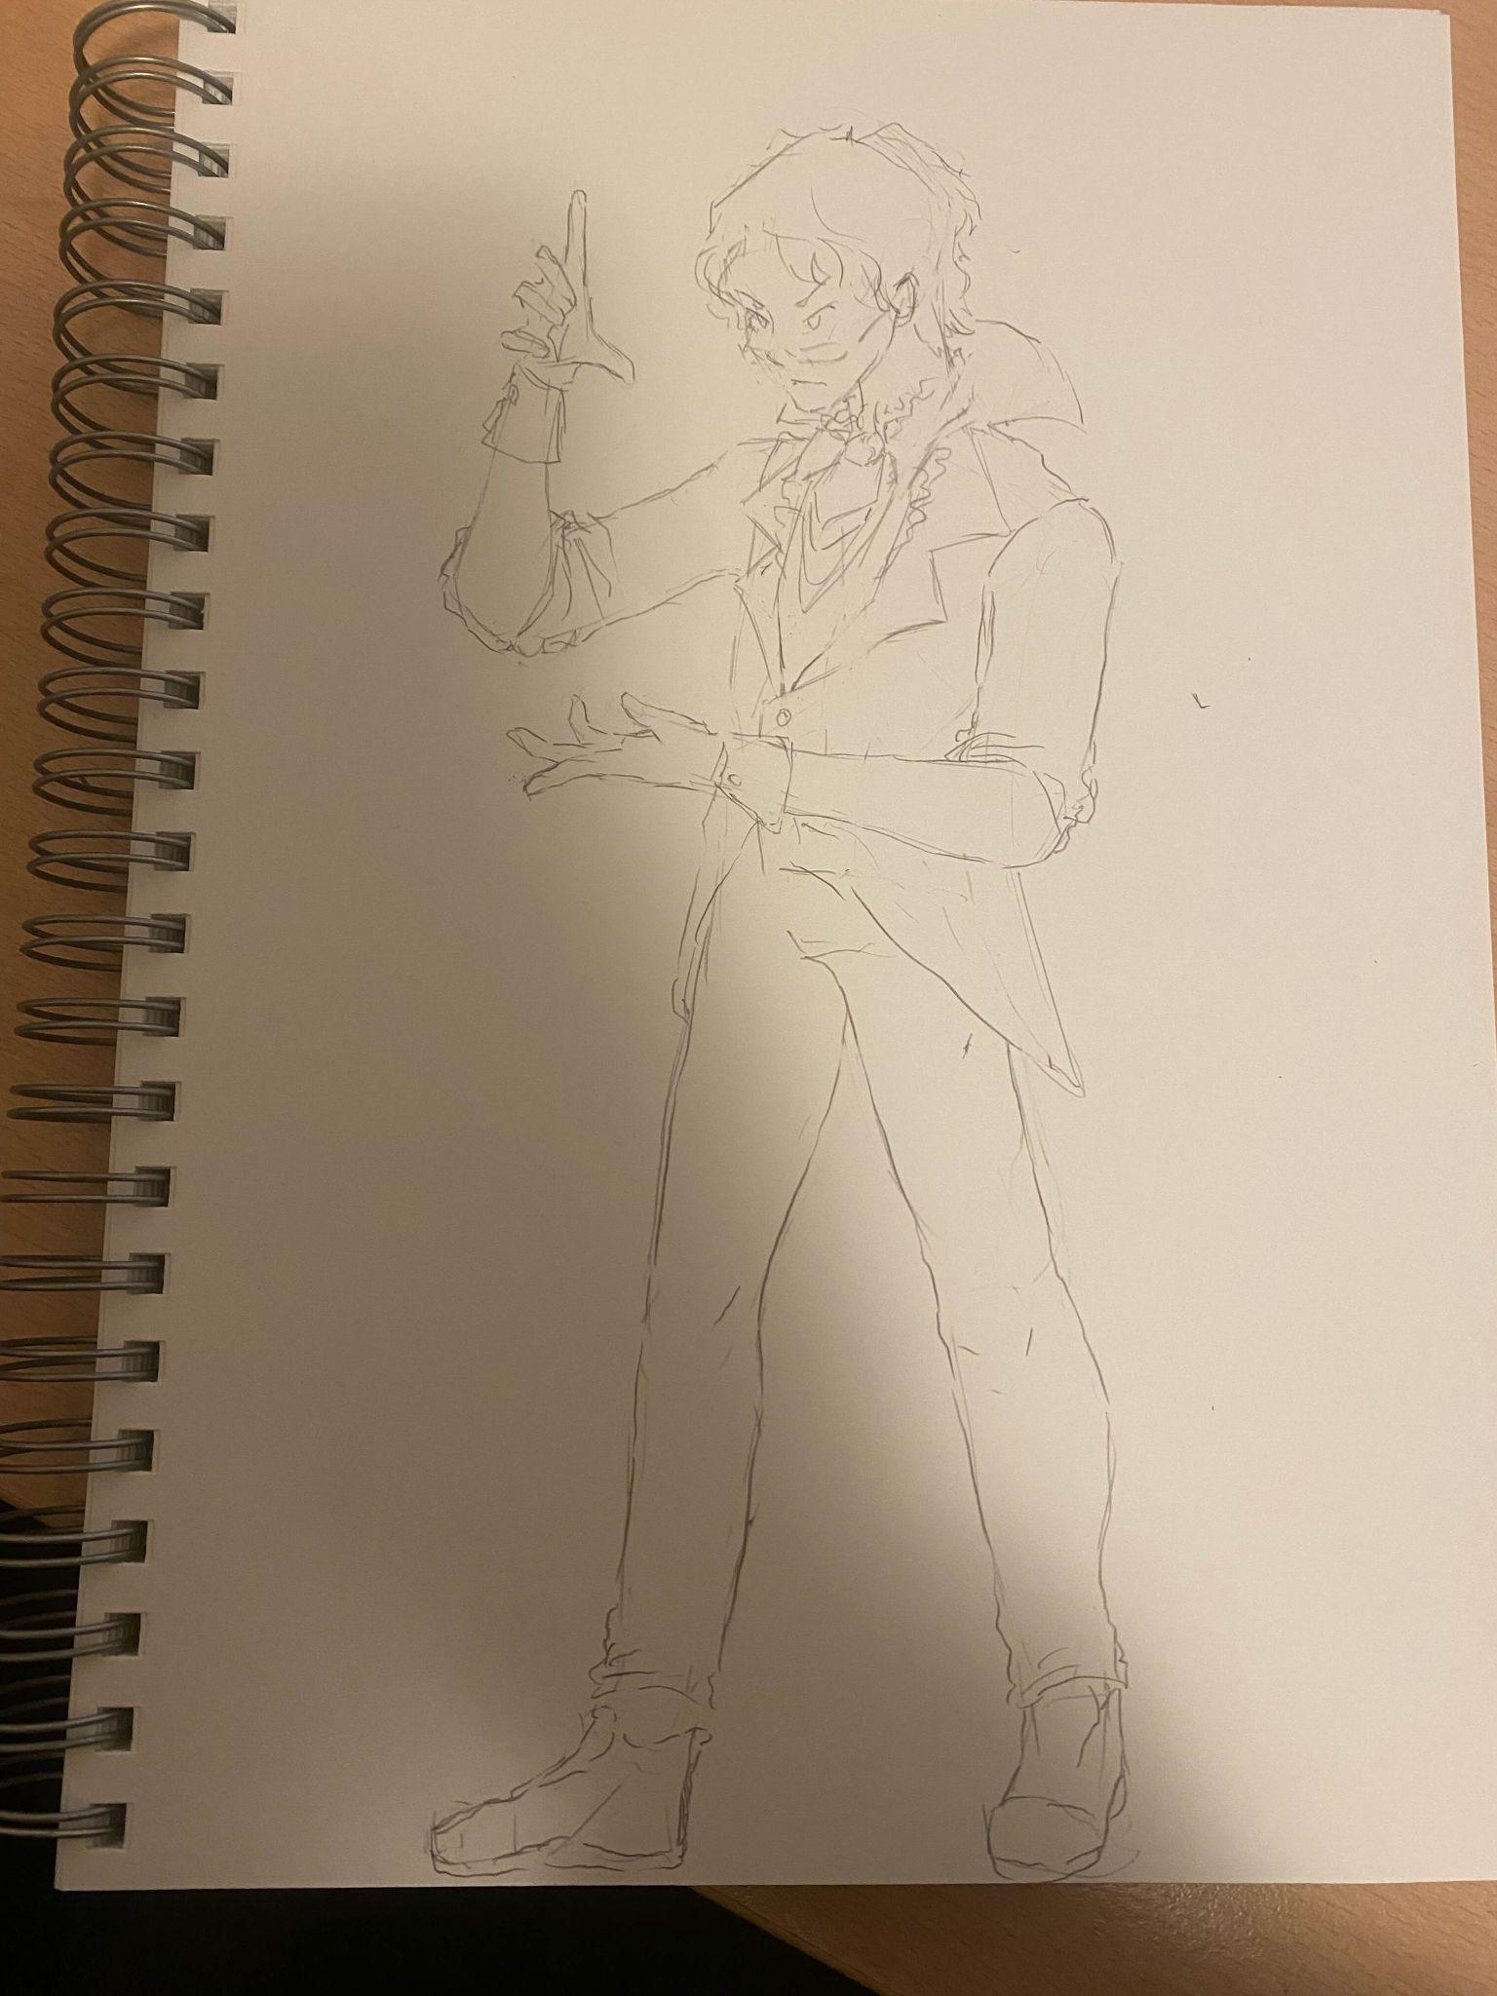

Expressions List:
- Serious. Use sketch expression for this one.
- Happy. Soft smile.
- Sad. Worried frown.
- Angry. Tense frown.
- Surprised. Perturbed shock reaction, big mouth open.
- Scared. Extreme fear reaction, gritting teeth, sweating.

Notes: Despite have a serious expression as default, Jonah is a very emotional person, which should be evident in his expressions. Most of his interactions in the game are with Lydia, so keep in mind he’s thinking of her while having them. During happy he’s happy for her, while sad he’s worried for her, etc.

Lydia Silvermoon

Pose: looking from right to left, directly in front of Jonah. Floating in a ghostly state, arms and legs resting in the air.

Expressions List:
- Numb. Blank, resting face.
- Happy. Soft smile, with a hint of hope.
- Sad. Soft frown, eyes looking down-right.
- Angry. Tense frown, eyes locked, gritting teeth.
- Surprised. Mild shock, mouth slightly open.
- Scared. Scared expression, in pain, worried. Wide eyes, open mouth.

Notes: Lydia for the most part has soft expressions due to the fact she’s used to suppress her emotions. She feels responsible for Jonah’s happiness, so shame and guilt can be added to some of her expressions.

Overseer

Pose: looking from right to left. Composed, business like, stoic.

Expressions List:
- Serious Relaxed, business face.
- Happy Satisfied, greedy smile.
- Frustrated Mild frustration, mouth scrunched to right side.
- Surprised Mild surprise, one eyebrow raised.

Notes: The Overseer is largely dispassionate and professional during his conversation with Jonah. He’s not concerned with dealing with human lives like Jonah is, displaying a cold, hard exterior.

